Team 10 - The Veil

What's new in this demo:

* Replaced Platform assets.
* We change a little level design to avoid player trapped in a dead loop.
* Fixed some animation and trigger bug.
* Reduced the difficulty in game.
* Reduced dialogue and polished the dialog box.
* Added a flashing block to indicate where the platform will go when used.

Current controls:

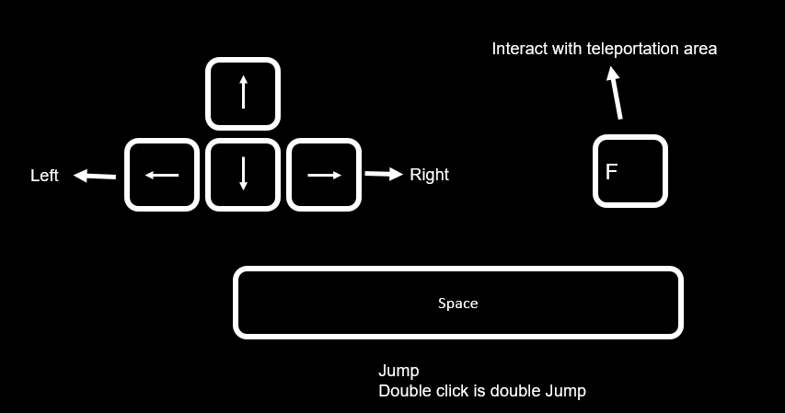

Known issues and bugs:

* The lever doesn’t have an animation for now.
* If you press Continue through the dialogue too quickly, the words will write on top of each other.

Future plan:

* Finish polishing the dialogue box, adding Wizard sprite.
* Fixing bugs.
* Finish implementing art and sound work.
* Adding environmental ambience to the soundtrack (will give player a greater sense of place and soften the harshness of SFX such as jumping and enemy units.)